Ex. No : 7
DEVELOP AN APPLICATION THAT MAKES USE OF RSS FEED
Date:

AIM:
To develop an android application that makes use of RSS Feed using android studio and sdk.

PROCEDURE:

Step 1 : File → NewProject
Provide the application name and Click “Next”

Step 2 : Select the target android devices
Select the minimum SDK to run the application. Click “Next”.

Step 3 : Choose the activity for the application (By default choose “Blank Activity). Click
“Next”.

Step 4 : Enter activity name and click "Finish".

Step 5 : Edit the program.

Step 6 : Run the application, 2-ways to run the application.
1. Running through emulator
2. Running through mobile device

SOURCE CODE:-

AndroidManifest.xml
<?xml version="1.0" encoding="utf-8"?>
<manifest xmlns:android="http://schemas.android.com/apk/res/android"
package="com.example.administrator.rss">
<uses-permission android:name="android.permission.INTERNET"/>
<application
android:allowBackup="true"
android:icon="@mipmap/ic_launcher"
android:label="@string/app_name"
android:supportsRtl="true"
android:theme="@style/AppTheme">
<activity android:name=".MainActivity">
<intent-filter>
<action android:name="android.intent.action.MAIN" />
<category android:name="android.intent.category.LAUNCHER" />
</intent-filter>
</activity>
</application>
</manifest>

activity_main.xml
<?xml version="1.0" encoding="utf-8"?>
<LinearLayout xmlns:android="http://schemas.android.com/apk/res/android"
android:layout_width="fill_parent"
android:layout_height="fill_parent">
<ListView
android:layout_width="match_parent"
android:layout_height="wrap_content"
android:id="@+id/listview"
/>
</LinearLayout>

MainActivity.java

package com.example.administrator.rss;
import android.app.ListActivity;
import android.content.Intent;
import android.net.Uri;
import android.os.AsyncTask;
import android.os.Bundle;
import android.view.View;
import android.widget.ArrayAdapter;
import android.widget.ListView;
import org.xmlpull.v1.XmlPullParser;
import org.xmlpull.v1.XmlPullParserException;
import org.xmlpull.v1.XmlPullParserFactory;
import java.io.IOException;
import java.io.InputStream;
import java.net.MalformedURLException;
import java.net.URL;
import java.util.ArrayList;
import java.util.List;
public class MainActivity extends ListActivity
{
List headlines;
List links;
@Override
protected void onCreate(Bundle savedInstanceState)
{
super.onCreate(savedInstanceState);
new MyAsyncTask().execute();
}
class MyAsyncTask extends AsyncTask<Object,Void,ArrayAdapter>
{
@Override
protected ArrayAdapter doInBackground(Object[] params)
{
headlines = new ArrayList();
links = new ArrayList();
try
{
URL url = new URL("http://rss.cnn.com/rss/edition_technology.rss");
XmlPullParserFactory factory = XmlPullParserFactory.newInstance();
factory.setNamespaceAware(false);
XmlPullParser xpp = factory.newPullParser();
// We will get the XML from an input stream
xpp.setInput(getInputStream(url), "UTF_8");
boolean insideItem = false;
// Returns the type of current event: START_TAG, END_TAG, etc..
int eventType = xpp.getEventType();
while (eventType != XmlPullParser.END_DOCUMENT)
{
if (eventType == XmlPullParser.START_TAG)
{
if (xpp.getName().equalsIgnoreCase("item"))
{
insideItem = true;
}
else if (xpp.getName().equalsIgnoreCase("title"))
{
if (insideItem)
headlines.add(xpp.nextText()); //extract the headline
}
else if (xpp.getName().equalsIgnoreCase("link"))
{
if (insideItem)
links.add(xpp.nextText()); //extract the link of article
}
}
else if(eventType==XmlPullParser.END_TAG && xpp.getName().equalsIgnoreCase("item"))
{
insideItem=false;
}
eventType = xpp.next(); //move to next element
}
}
catch (MalformedURLException e)
{
e.printStackTrace();
}
catch (XmlPullParserException e)
{
e.printStackTrace();
}
catch (IOException e)
{
e.printStackTrace();
}
return null;
}
protected void onPostExecute(ArrayAdapter adapter)
{
adapter = new ArrayAdapter(MainActivity.this, android.R.layout.simple_list_item_1, headlines);
setListAdapter(adapter);
}
}
@Override
protected void onListItemClick(ListView l, View v, int position, long id)
{
Uri uri = Uri.parse((links.get(position)).toString());
Intent intent = new Intent(Intent.ACTION_VIEW, uri);
startActivity(intent);
}
public InputStream getInputStream(URL url)
{
try
{
return url.openConnection().getInputStream();
}
catch (IOException e)
{
return null;
}
}
}
OUTPUT:-

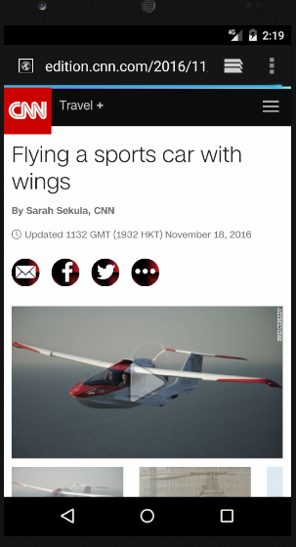
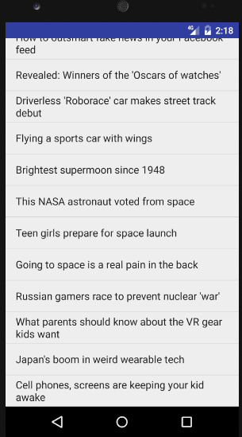

RESULT:
Thus the android application that makes use of RSS Feed using android studio and sdk was developed successfully.

